# CS 255 System Design Document Template

## UML Diagrams

### UML Use Case Diagram

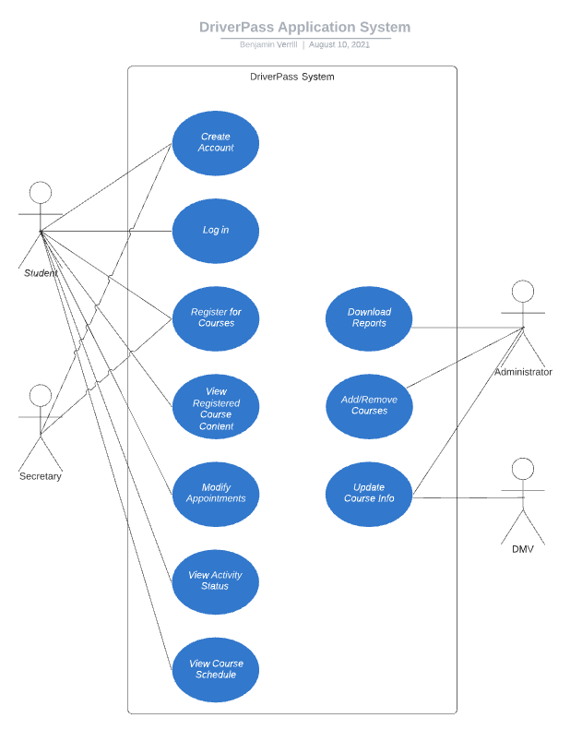

### UML Activity Diagrams

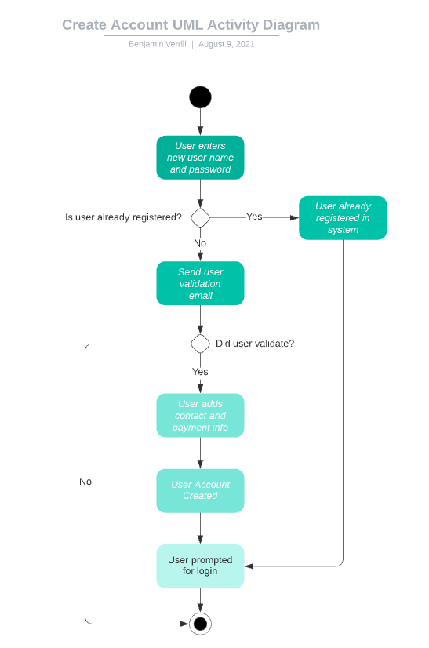

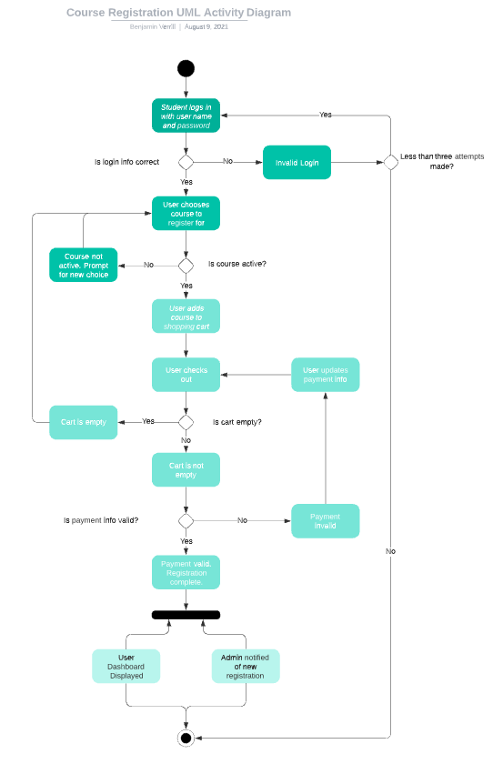

### UML Sequence Diagram

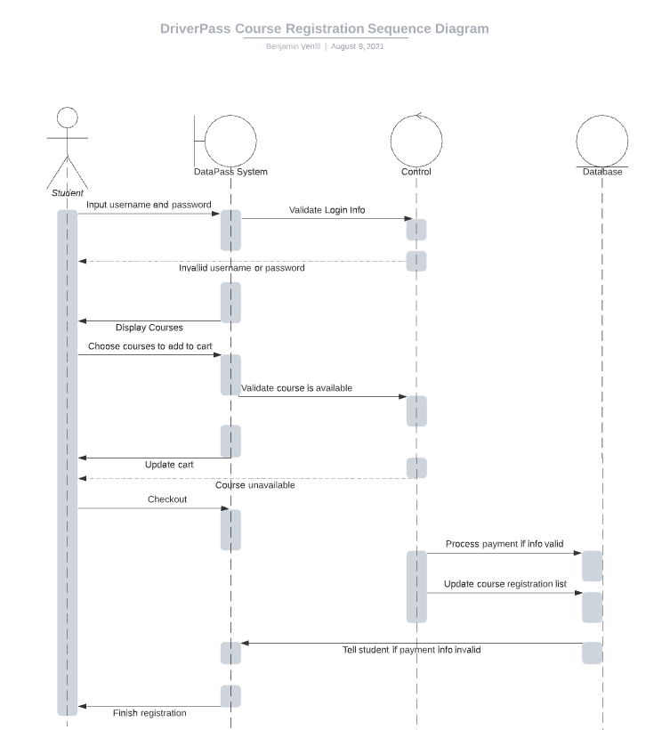

### UML Class Diagram

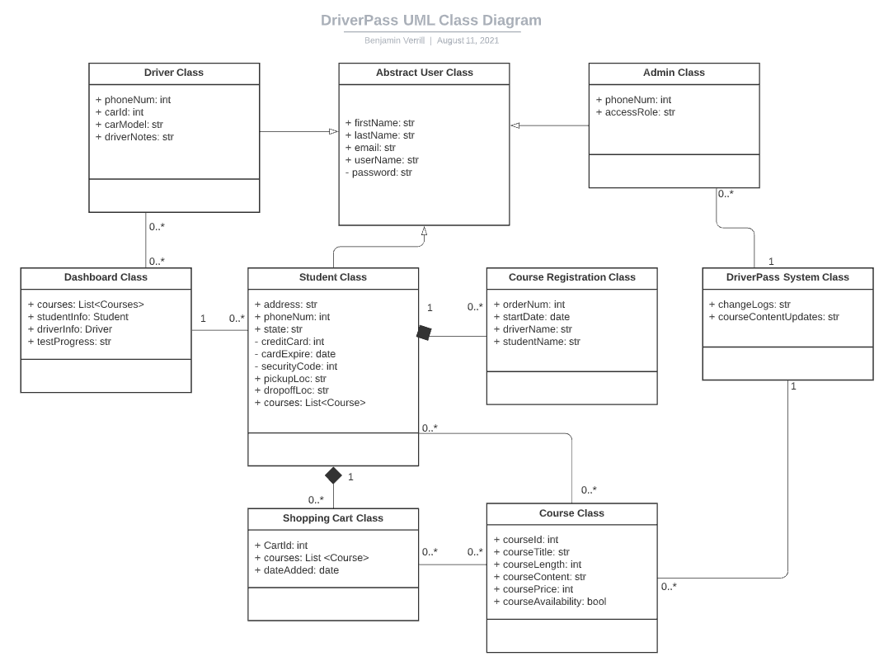

## Technical Requirements

* Hardware
  + No hardware is required as this will be a cloud hosted solution. All hardware requirements will be handled by the cloud provider.
* Software
  + Latest Windows Server operating system with SQL. We’ll use Windows IIS to host the app and a SQL database for storing data.
  + Privilege Access Management security software
* Tools
  + VS Code IDE for coding
  + React Framework for building a web application compatible with multiple web browsers
* Infrastructure
  + AWS EC2 instance for hosting web server and database